**Modeling**

Use Case Diagram:

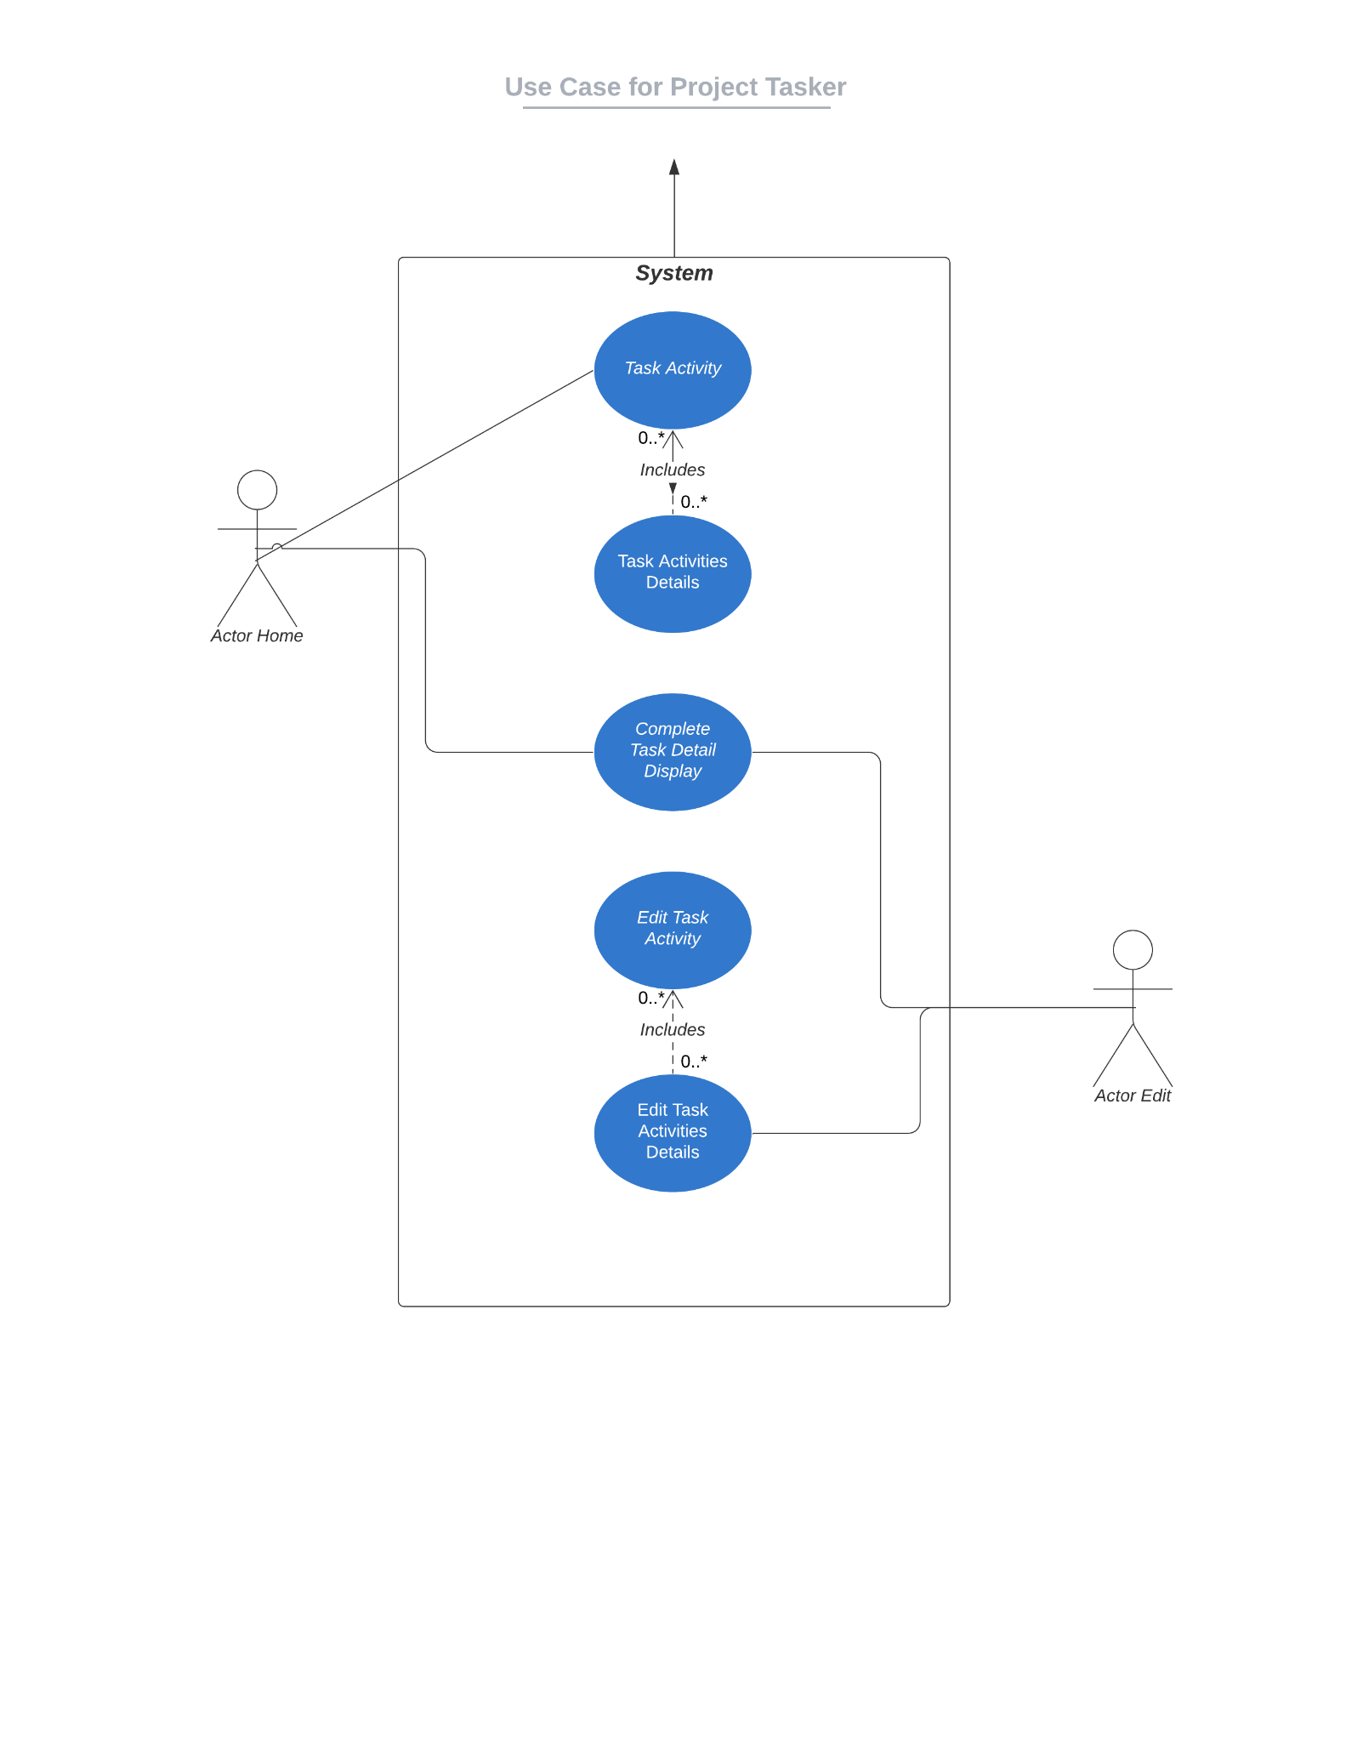

*Use Case 1. You load the page and see the initial screen.*

|  |  |
| --- | --- |
| **Use Case Name** | Home Screen. |
| **Actor** | Actor Home. |
| **Precondition** | Load the page. |
| **Description** | It is the main menu, where you enter the main data. |
| **Post Condition** | View the create task window and details. |

*Use Case 2. Save Initial Task*

|  |  |
| --- | --- |
| **Use Case Name** | Save Master Entry. |
| **Actor** | Actor Home. |
| **Precondition** | View Create Task Screen on Home Page. |
| **Description** | Here you can see all the main fields like, Order No, Customer, Machine Detail, Activity and dates. |
| **Post Condition** | Will click on + icon. |

*Use Case 3. Save Task Details*

|  |  |
| --- | --- |
| **Use Case Name** | Save Task Activities. |
| **Actor** | Actor Home. |
| **Precondition** | Saved Task Master of above. |
| **Description** | Here you can see all the detail fields like Department, Resource, Number of Resource, Hour, Duration & Start Date. |
| **Post Condition** | Will click on the SAVE Button, we can either go in the Edit window or Display. |

*Use Case 4. View Task Detail*

|  |  |
| --- | --- |
| **Use Case Name** | Display Saved Task Details |
| **Actor** | Actor |
| **Precondition** | Saving of Task Details and All its activities |
| **Description** | Here you can view all the master activities and its details on one screen. |
| **Post Condition** | You have three buttons i.e. Home Edit Display on top, from where you can go to Home or Edit also. |

*Use Case 5. Task Edit*

|  |  |
| --- | --- |
| **Use Case Name** | Edit the Saved Task |
| **Actor** | Actor Edit |
| **Precondition** | Saving of master Tasks should have been done before and ID should have been allocated. |
| **Description** | You can edit all the tasks and task detail activities. |
| **Post Condition** | Display on top, from where you can go to the display menu to view the edit record. |

*Use Case 6. Task Edit Activities*

|  |  |
| --- | --- |
| **Use Case Name** | Edit the Saved Task Detail Activities |
| **Actor** | Actor Edit |
| **Precondition** | Edit of Tasks, needs to be edited previously. |
| **Description** | You can edit all the task detail activities. |
| **Post Condition** | Display on top, from where you can go to the display menu to view the edit record. |

***Class Diagram of Project Tracker***

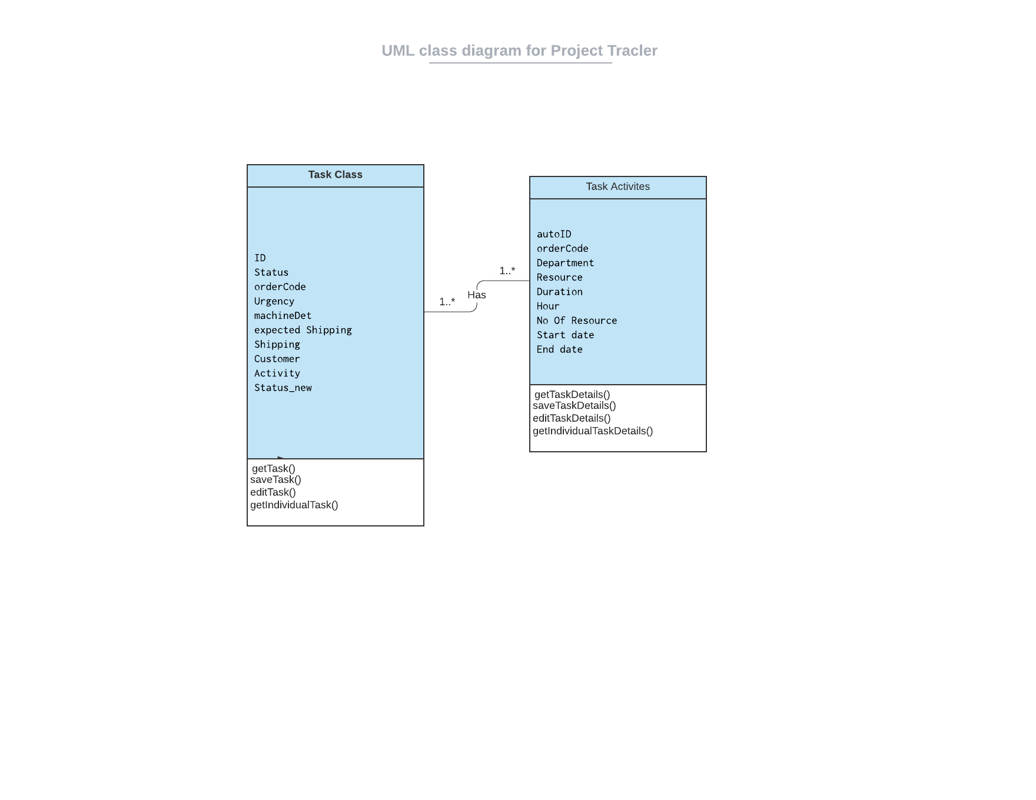

*Interesting Code Snippets:*

1. Create an empty Task:

This is used to create an empty task for the system to use for saving the further ones.

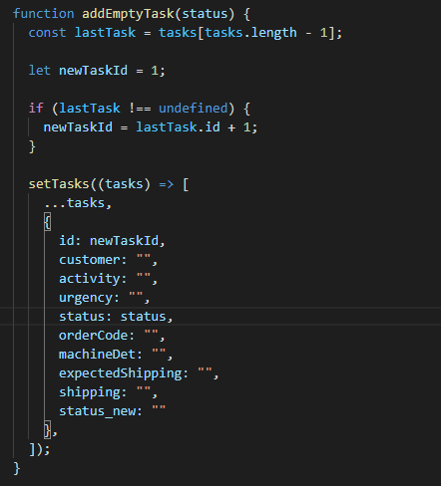

1. Saving of Task Entry:

Save the Maste Task to local storage as well as on our database sever. Here you can see our live database is on the localhost and on port 3000. And also the api is mentioned.

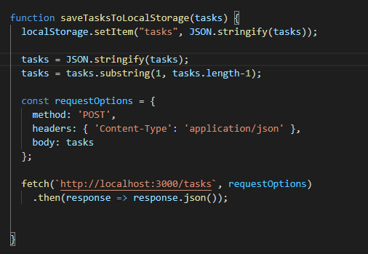

1. Delete Task:

This is used to delete tasks from our live database and then the filtered task methods run and update the screen as well.

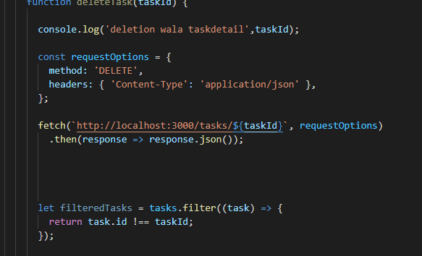

1. Display Task:

This the class component used to fetch the data from the database and then the update state to save the value.

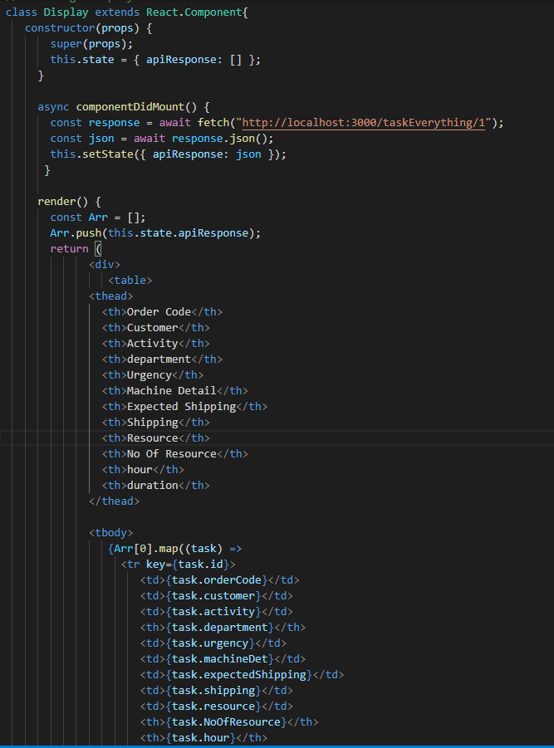

1. Loading tasks for Task Edit:

Here all the tasks from our database, using the api, are called and then pushed into an array and set into the setTasks hook, which then renders and updates the task activities.

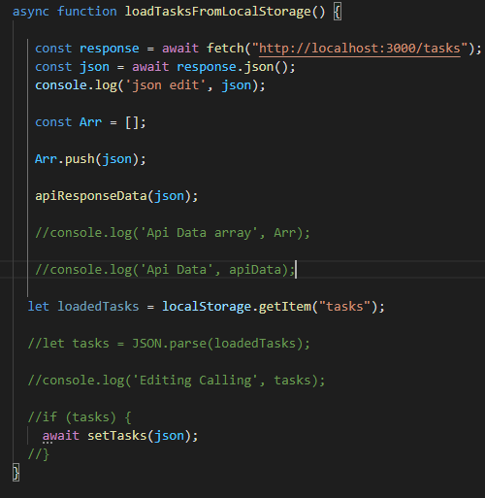

1. Here is how task activity is created:

Following data model has been used to insert the values received in the tasks table. If there is an error, we send back the error, if not we send an insert ID as an result.

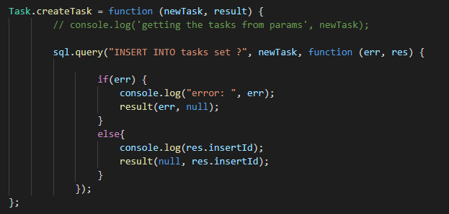

1. Get Individual record from tasks:

Following API function is used for getting all the data from the tasks function. We have called the individual columns and also formatted it.

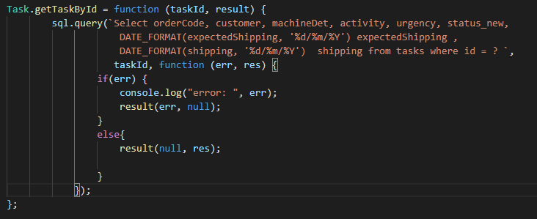

How to use the front end/client side:

1. After running up both the servers.
2. Open Web Browser and enter “localhost:2000”.
3. Here the Home Screen is where you save the task detail.
4. Enter all the correct input values, for their respective fields.
5. After confirming and re-checking, click on the save button.
6. Then below there is **+** symbol used for saving all task activities.
7. Click on it and the new field will populate for task activities.
8. Save with the relevant data and with respect to the task activity added above.
9. If there are more than one task there is **+** symbol to add more.
10. You can also delete it with the red **X** Button, which will remove it from the screen as well as from the database.
11. After saving you can click on the display button to view the saved record.
12. Here on the screen you can see all the saved data from current and old activities.
13. If you want to edit any task or its activity you can click the edit button.
14. Whatever the task you want to edit, click edit and update the text box with the desired values and press save.
15. If you want to update the task details, you can do that as well.
16. Click edit on that record and update the task activities.
17. You can also add new records in task details from here.